1. Brief introduction about the project.

Hotel Management System software is a comprehensive technology solution designed to manage and automate daily hotel operations. It includes many functions such as room management, room booking, service management and financial management.

This software helps hotels optimize work processes, reduce time and effort, thereby improving performance and service quality. It also helps hotels provide a better experience to customers through providing accurate and quick information.

The project is developed based on Java and JS languages. The project uses Reactjs, HTML, CSS, MUI libraries for Front-end development, using Spring Boot framework and MySQL database for Back-end.

The project is developed according to agile method.

2. Present screenshots/video links demoing main functions

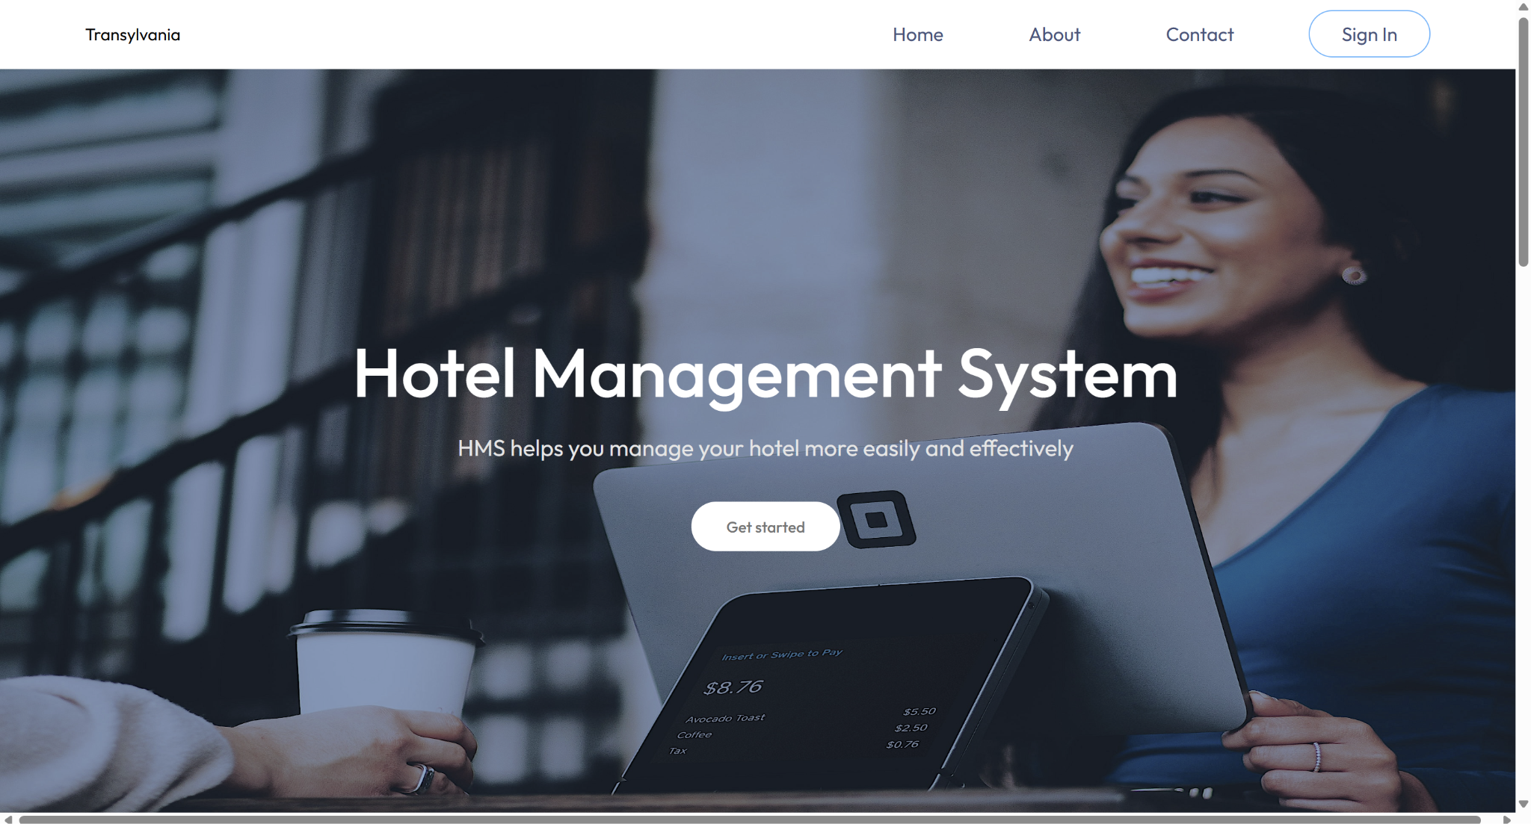

Home Header and Content

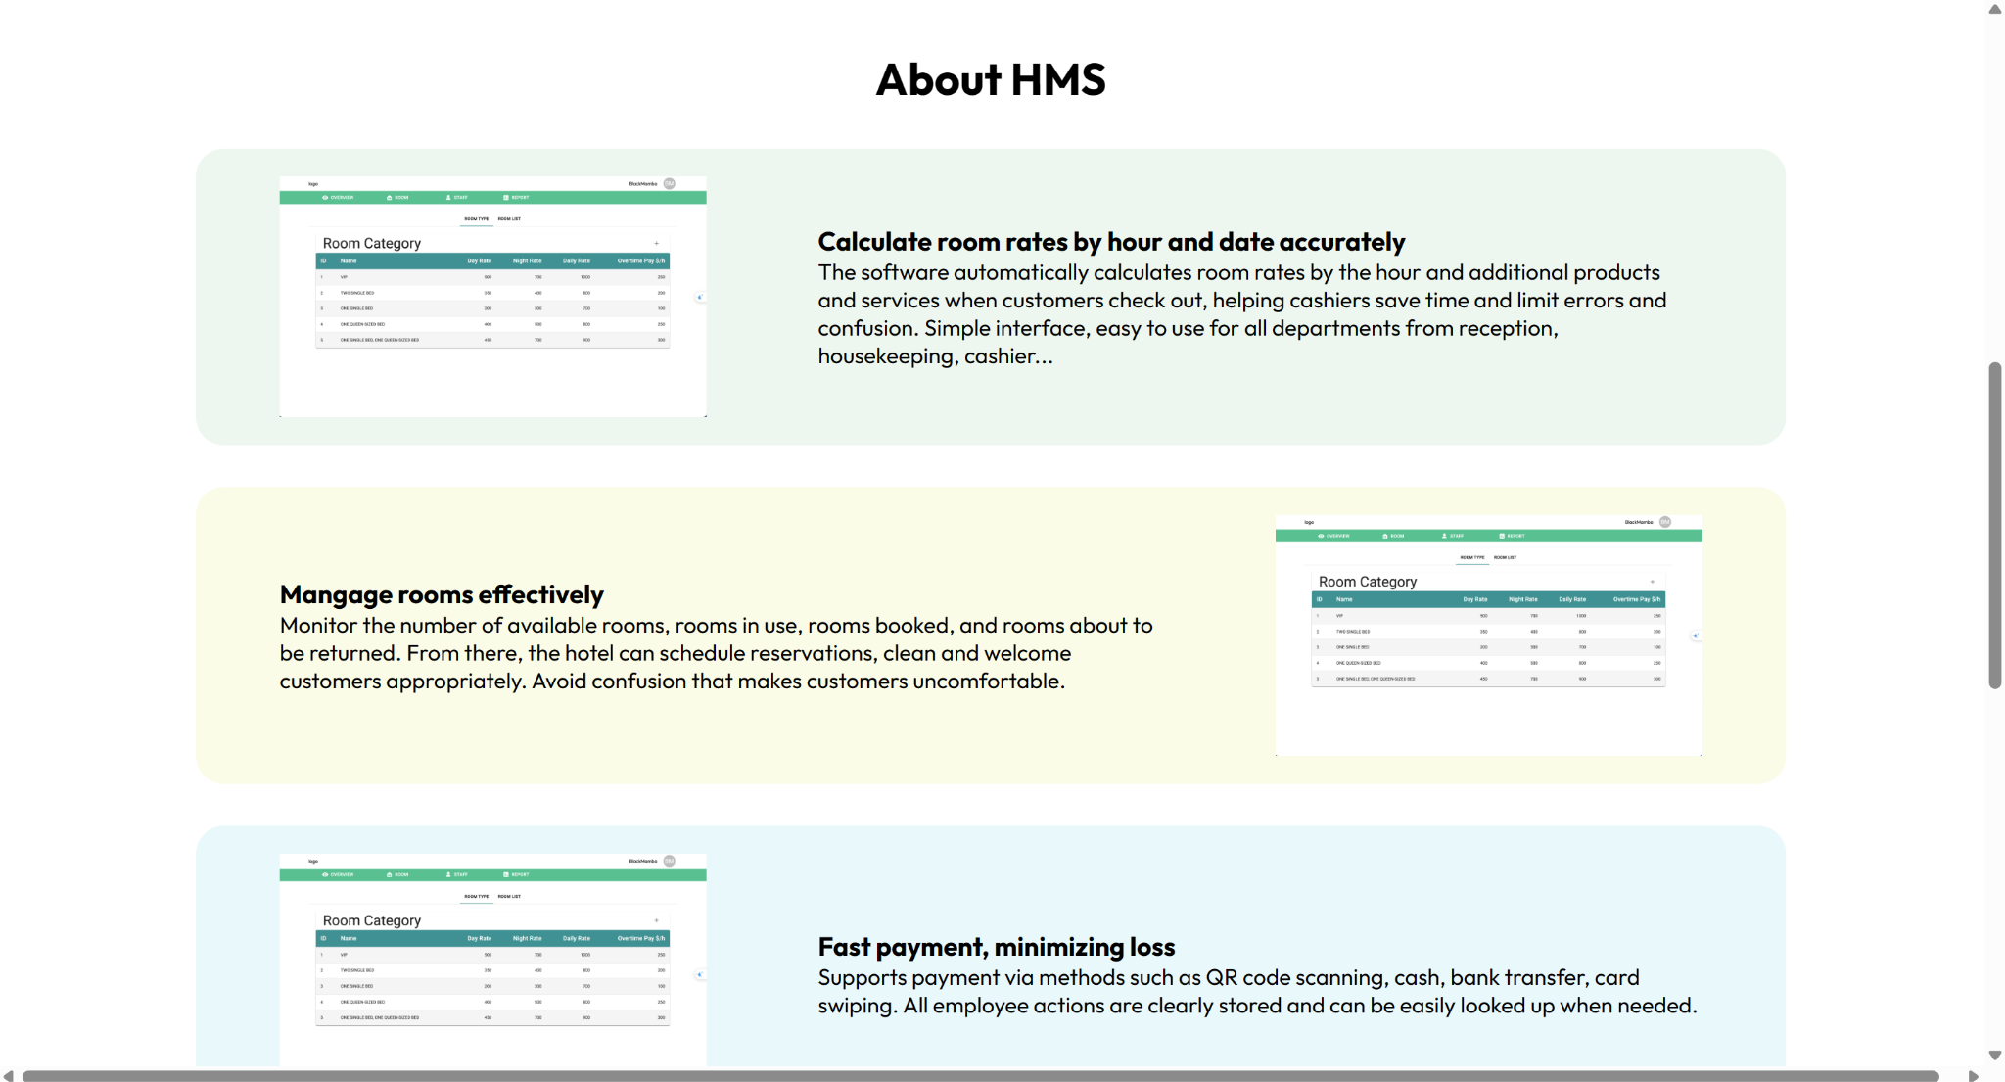

Home About

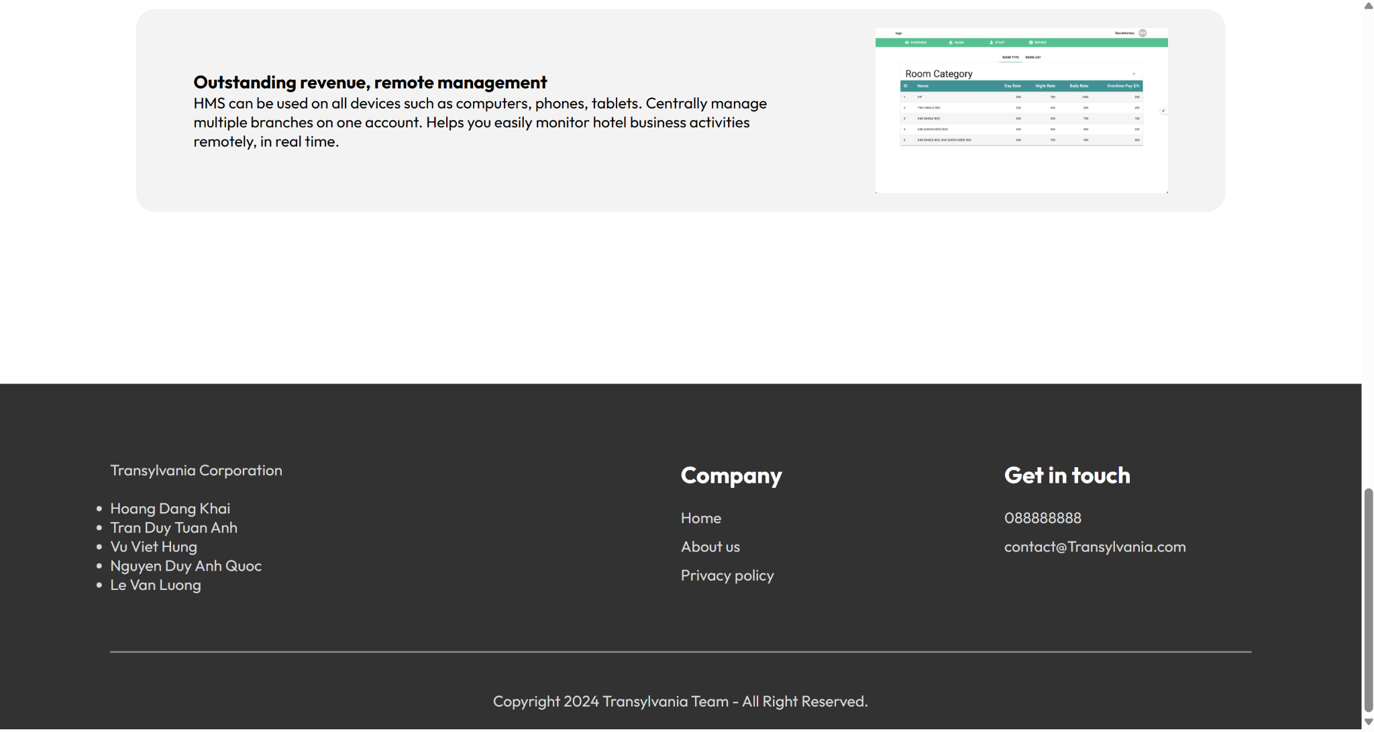

Home About and Contact

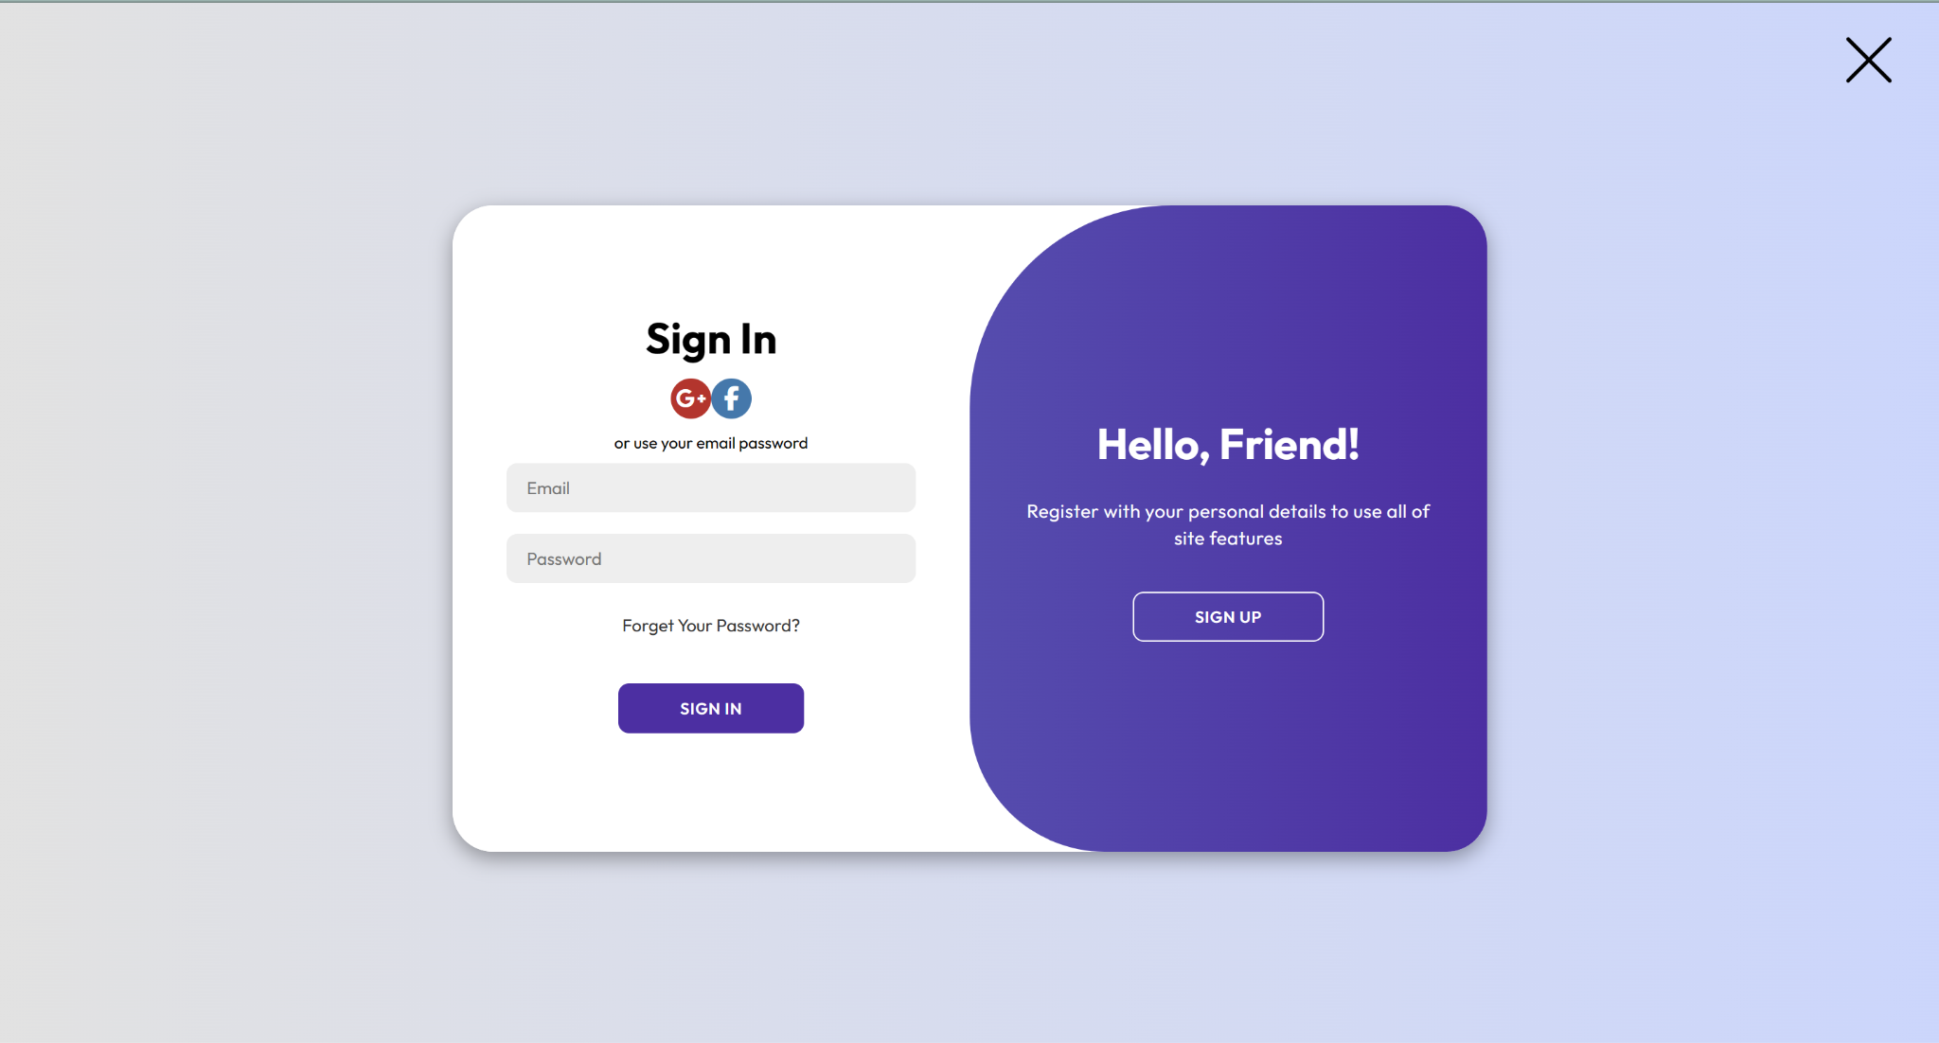

Login

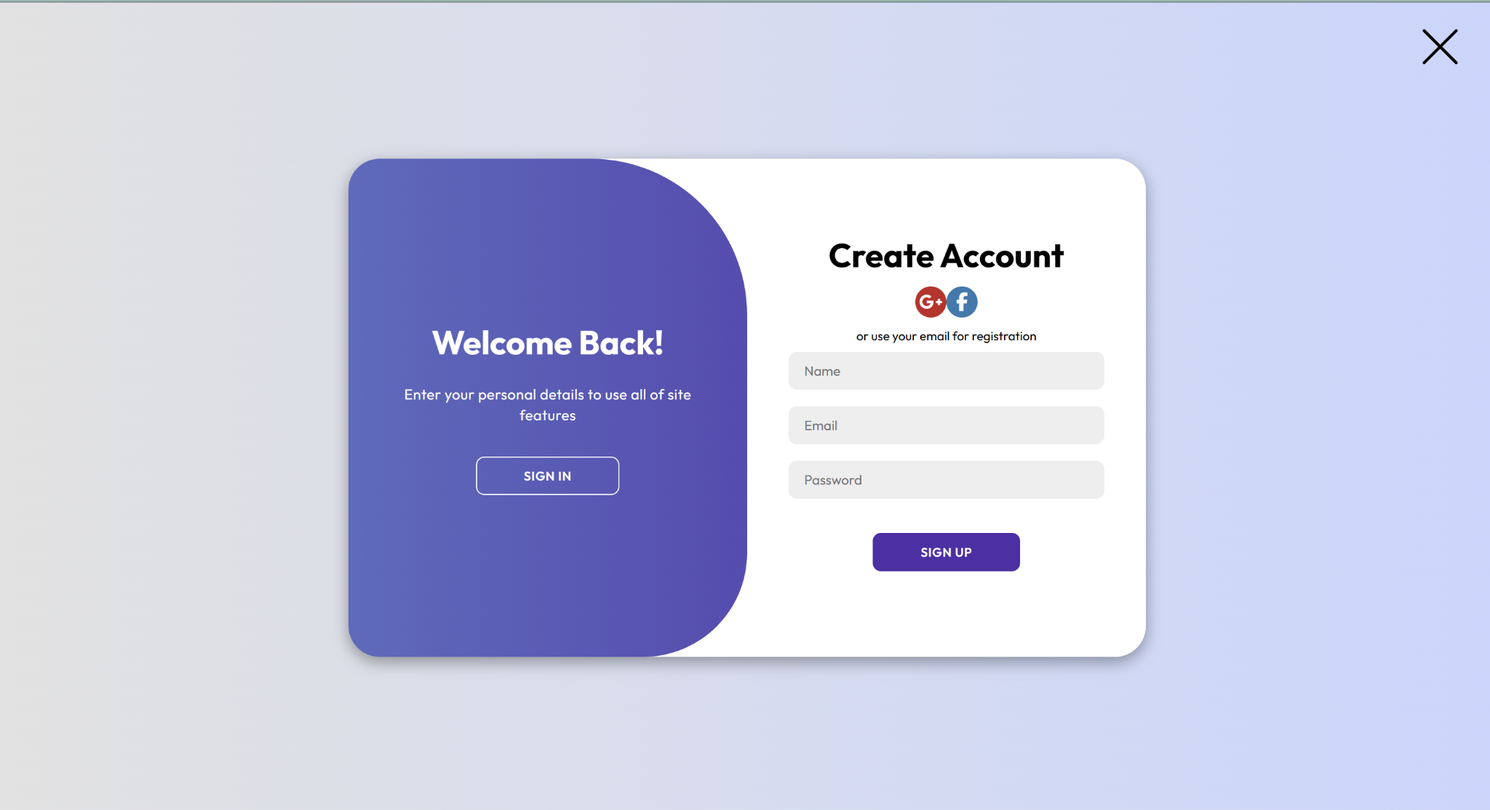

Register

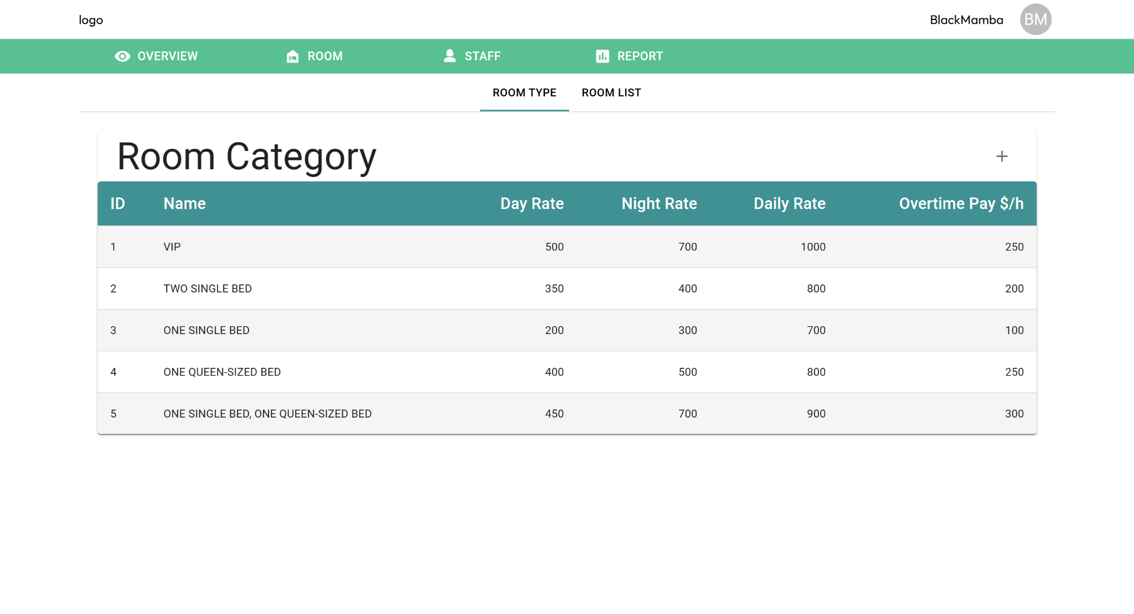

Type of Room

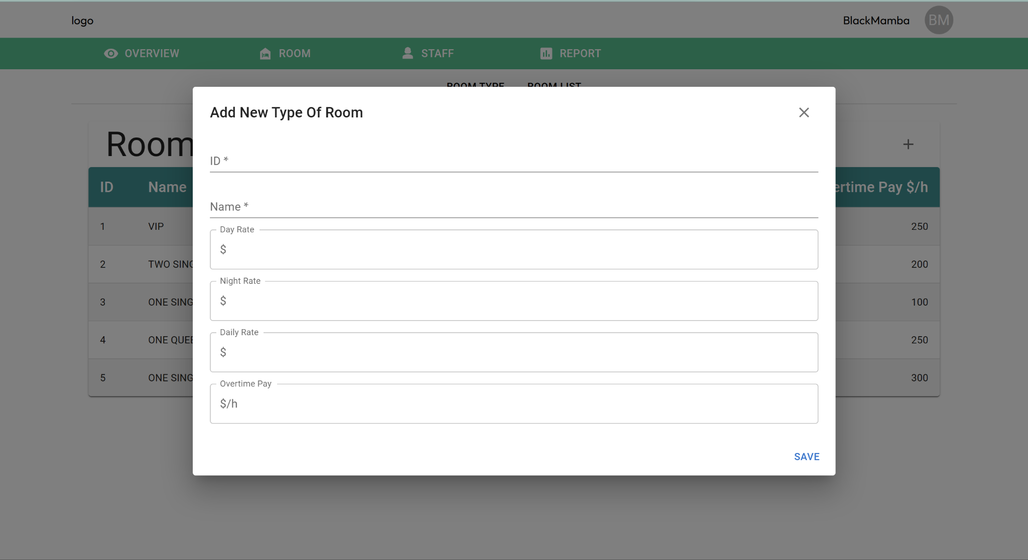

Add new type of room



Delete Type of Room Button

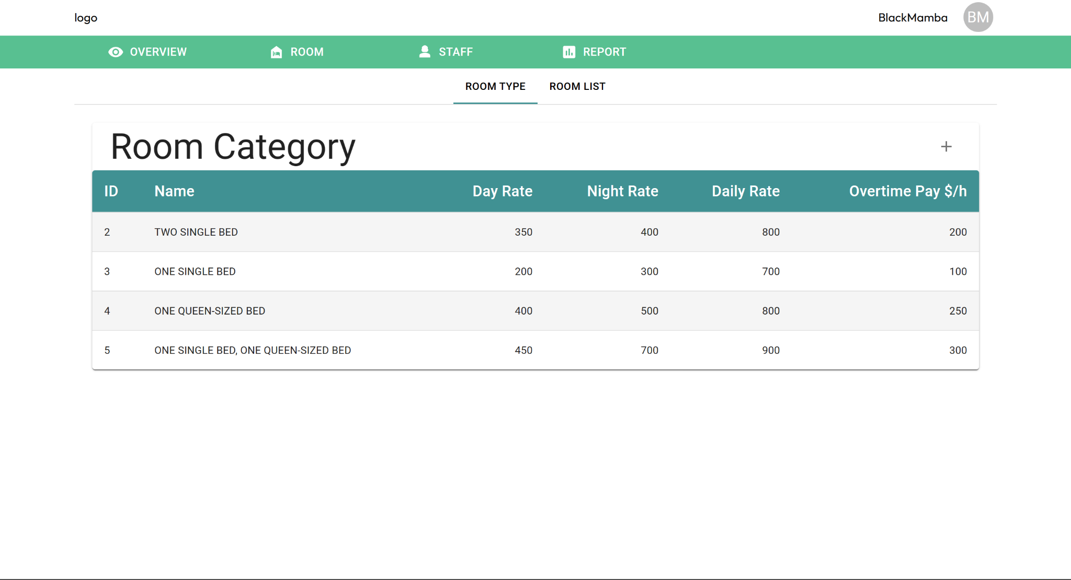

Selected Type of Room Disappear



Edit Type of Room Dialog

Room List

Edit Room Information

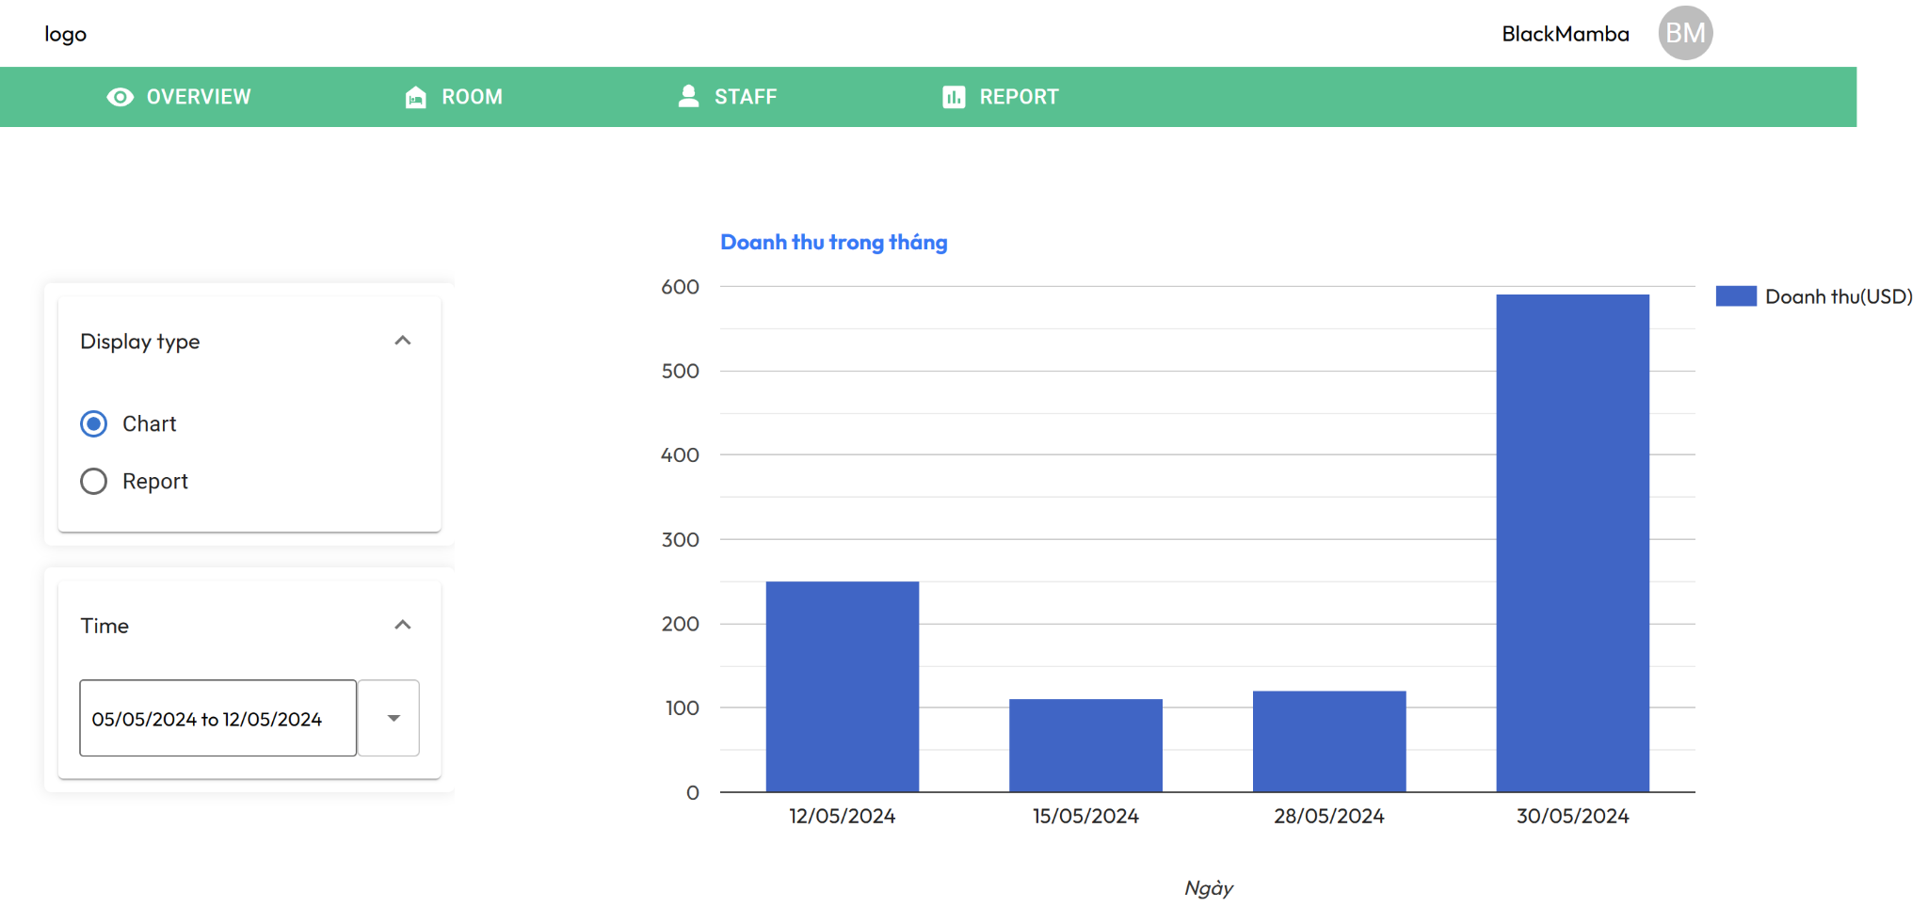

Room Booking Chart

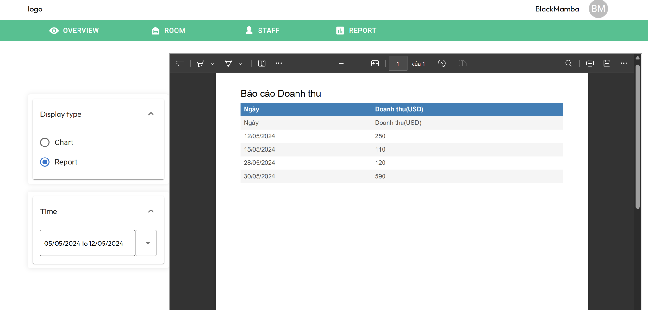

Room Booking Report

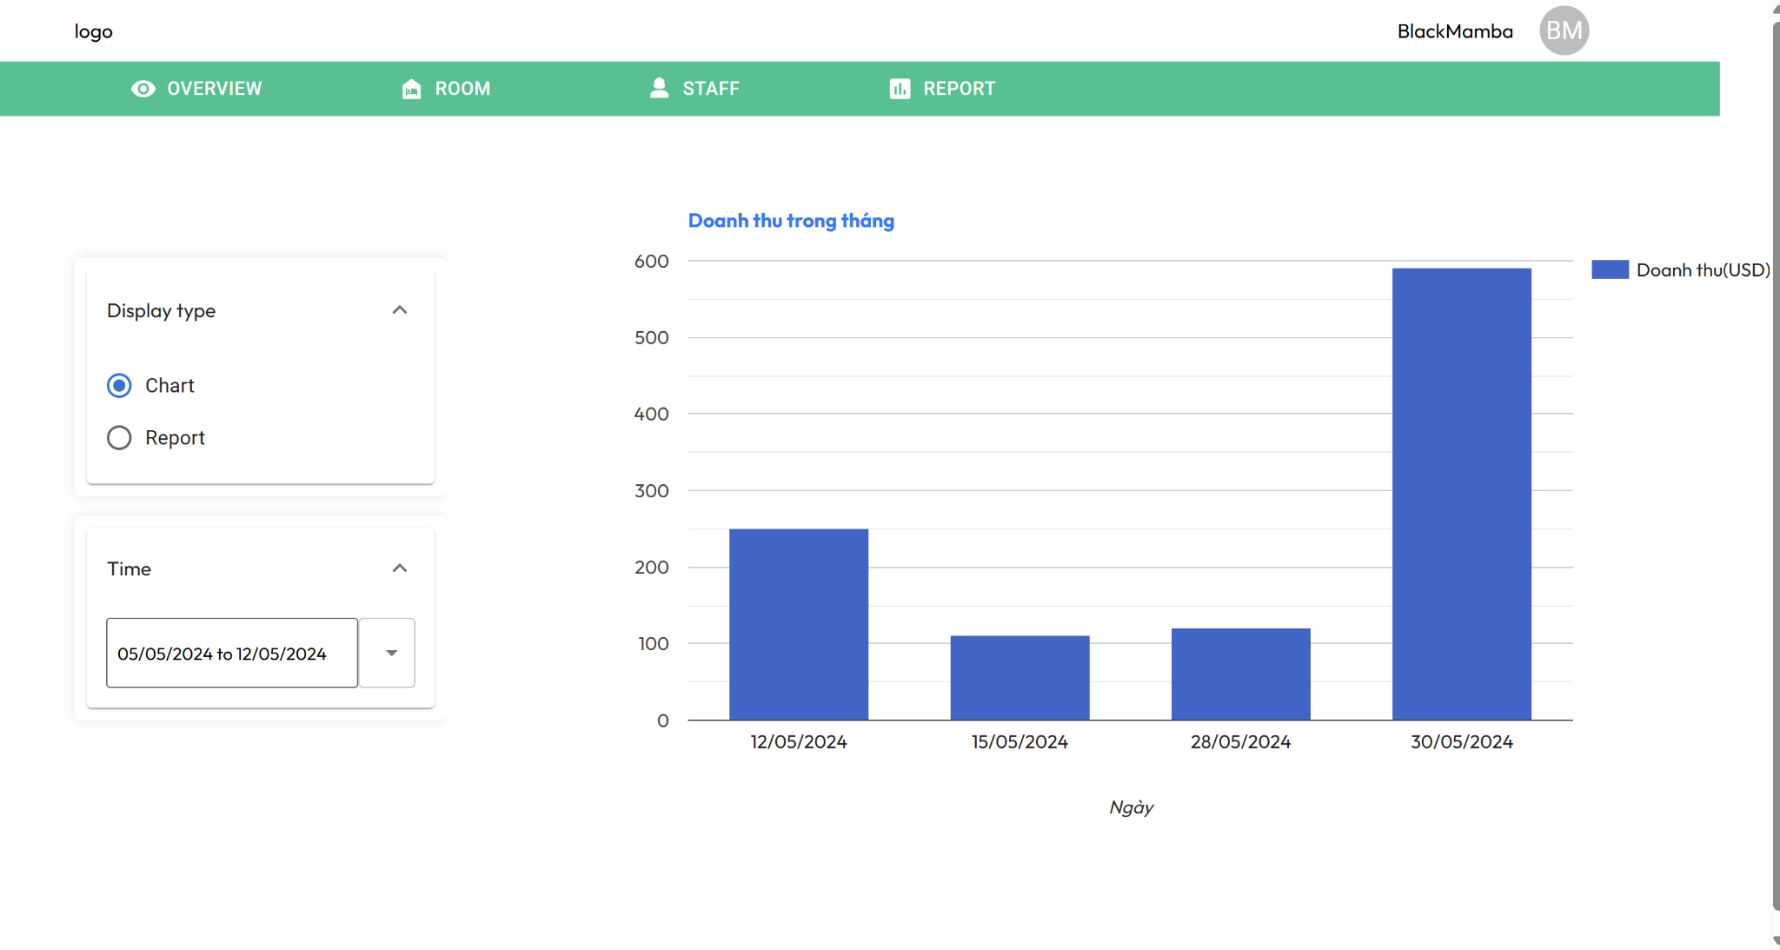

Revenue Chart

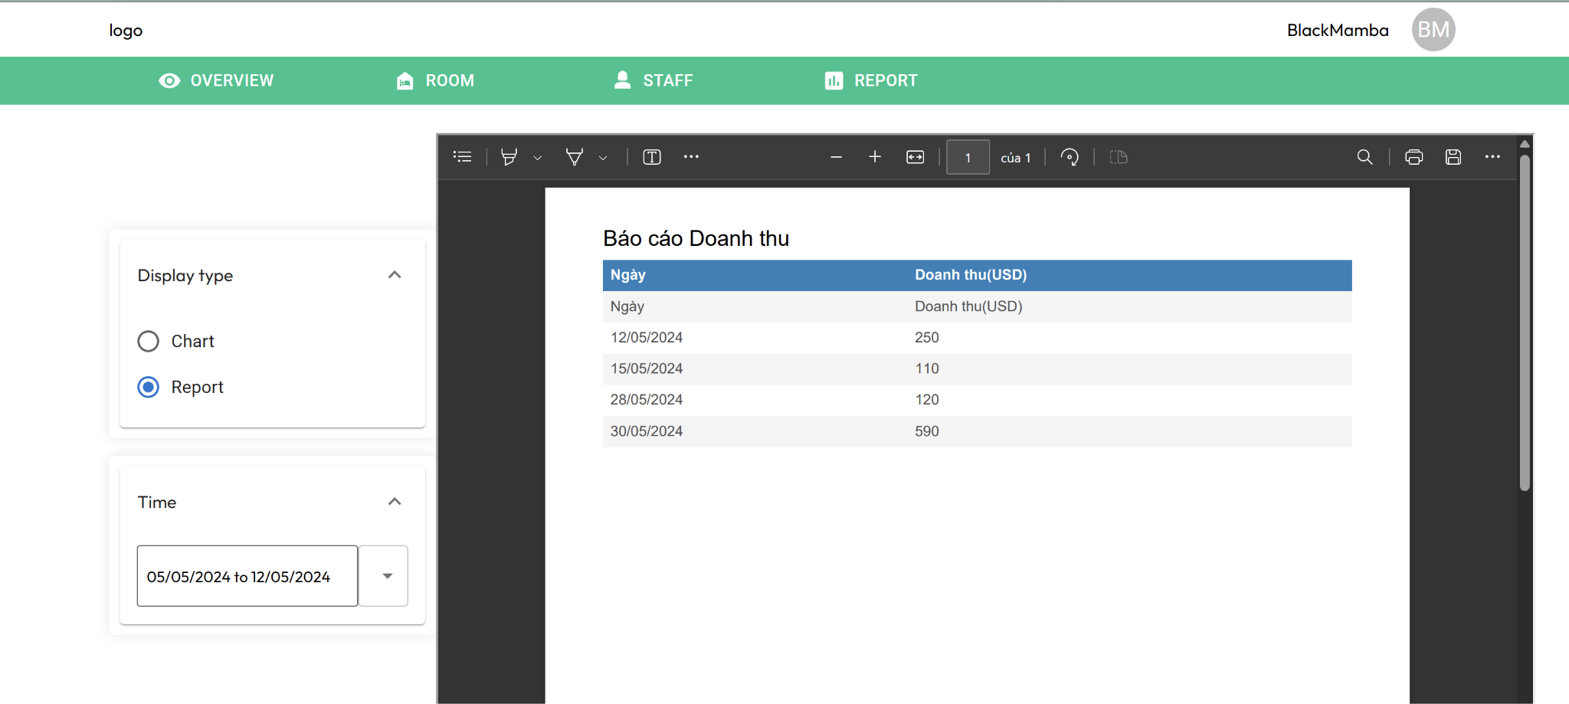

Revenue Report

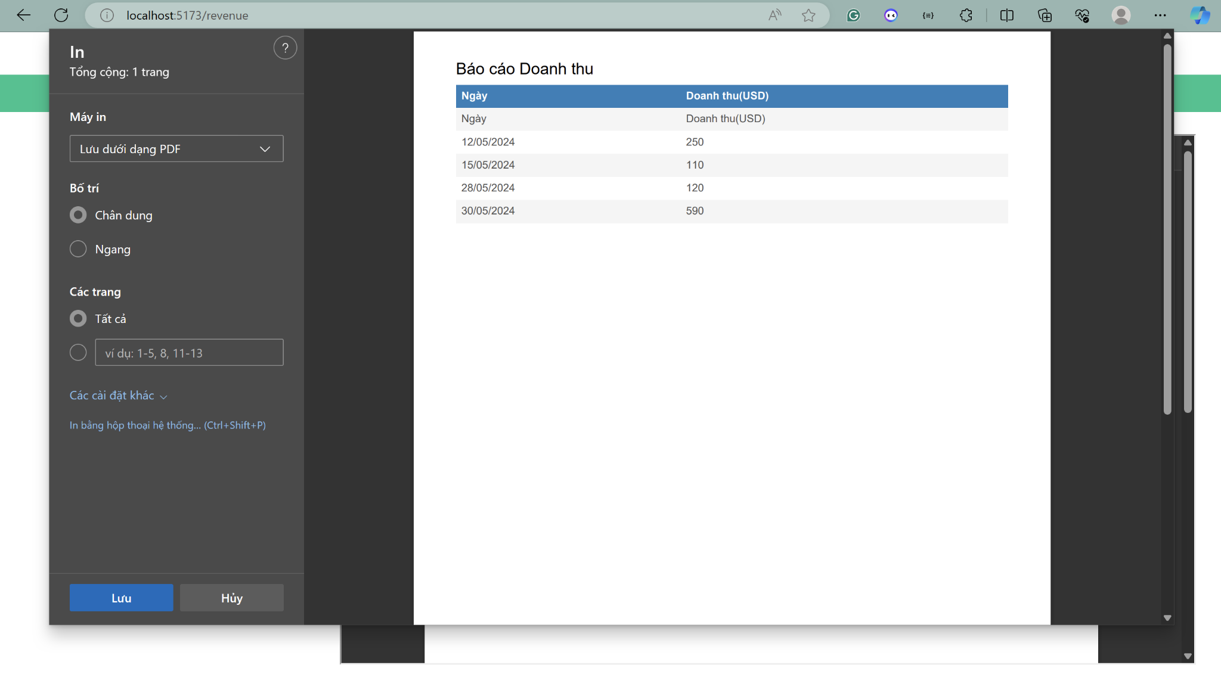

Print Report

3. Explain how these functions work (main thread + sub thread)

3.1 Login:

Step 1: First, the user sends login information to the website, then the website sends that data to the server for the backend to process.

Step 2: Backend authenticates login information using an intermediate class called AuthenticationManager, where user login information will be uploaded and compared with data on the database (encrypted password).

Step 3: The backend sends authentication information successfully or not to the web so that the web can display it to the user. At the same time, the backend will create a session for the user if the user logs in successfully.

3.2 Registration:

Step 1: The user sends registration information to the web and the web sends data to the server for the backend to process.

Step 2: Server checks the validity of registration information as follows:

+ Check if the username already exists, if not, it will return unsuccessful registration with the reason "username already exists".

+ If the username already exists, the server sends the authentication code via email, the user will enter the authentication code, the server will check if the code is valid, if valid, push the registration information to the database and send a registration notice. Register successfully, otherwise send a registration failure notification.

3.3 Present list of rooms:

Step 1: The employee will log in to the system, then send a query to the server to get room information.

Step 2: As soon as the server receives a request from the client, the server will query the database in the room table to retrieve the rooms of that hotel.

Step 3: After getting the data, it returns it to the server, and the server returns it to the client

3.4 Create booking:

Step 1: The receptionist will open the Booking Room dialog box for customers to select room type and quantity. Then send the request to the server.

Step 2: The server sends a request to search the database for suitable and available rooms. Then the data is sent to the server.

Step 3: Customers choose a room from the list of suitable and available rooms. And send payment request to the server.

Step 4: Server returns the total amount.

Step 5: The customer pays a prepayment and provides user information to the Server.

Step 6: The server stores user information in the database along with the prepaid amount

3.5 General report

Step 1: The manager sends a request to view the hotel's report, the website will send that request to the server for processing.

Step 2: The server will retrieve data from the database to display to the manager, then the manager will choose to report at any time (for example in April 2024), this information will be sent to the server for processing.

Step 3: The server searches for information recorded during that period of time. If not found, it sends a "Not found" message. If found, sends it to the manager.

4. Challenges/Proposed solutions

* Challenge: Not responsive, if using mobile the software is still not responsive.
* Proposed solutions: must use media screen in the css section to change the style of components when the screen is of different sizes.
* Challenge: Can't guarantee the software has no defects, bugs,... because it hasn't been tested much.
* Proposed solutions: create a unit test suite, use junit, contact someone with experience in testing to help advise on creating tests for the system.